# 491 Project Review

## Group 16

## Holden Brown, Cayden Kelley, Chase O'Connell, Tejal Devshetwar, Blake Hardy, Cameron Jones

## 

1) Summarize your team's progress thus far. What major milestones have you accomplished?

Our team has made significant progress in user interface, prototype, and software. The user interface for our plant care application was developed within the first couple weeks of last semester and has evolved and has since been almost entirely implemented in code. The prototype design has a working sensor and microcontroller that reads moisture data back. On the software side of things most of the app is complete in code and with a backend running on a server. The next significant milestone our team is working on is completing a round-trip with data from the moisture sensor, which means sending data from the microcontroller through the servers to the mobile app where the end user can see it. For the most part, the round trip is complete in software; it just needs to be connected.

2) Summarize the feedback you received from the faculty panel and others at the end of 491.

Our team did not receive much feedback during our presentation at the end of EE 491. The feedback we received was mostly concerned with knowing the expected range of the various nutrients to be considered “healthy” for different plants. This is an important aspect of our project because we are designing a system that is to apply water and fertilizer only when necessary. The nutrient levels necessary will vary depending on the type of plant and its environment. We also received feedback to make sure that we begin testing our fertilizer applicator and nutrient sensors as soon as possible to work out as many of the potential glitches in the system as possible. One final point our faculty panel mentioned was the inclusion of different notifications depending on the needs of each individual plant. This was mentioned to increase the accessibility of our application and the overall usability of our system.

3) What did your team do well (e.g., technical design, working as a team, meeting user needs)?

Our team is well-rounded in terms of skill and works well together as shown by our strong progress the first semester. The various components are progressing well and this semester will focus mainly on finishing up the major parts and integrating them into the whole. The mobile side of the app is nearly finished, the hardware is progressing, and the power delivery system is planned for this semester. All significant steps are planned out, and the technical design is solid even if some parts do need to be fleshed out, but that will be done as progress is made. All necessary end-user functionality is accounted for in the current plan.

4) What does your team need to improve upon in 4920?

While our team has done well on design decisions and making technical progress on the device, we have had a couple of issues in terms of time management, communication, and other related soft skills. The largest issue we faced in the previous semester was primarily a lack of time spent on the project. We were able to prototype the device and app with the time we did spend, however, we have a lot of room to improve on overall productivity. Additionally, we need to improve on making sure each member is participating consistently in team meetings and actively contributing their thoughts and opinions. Previously, we had some issues with some members missing meetings.

While we are doing well in general on the technical implementation of the project, we are still facing a major roadblock of trying to implement the NPK soil sensor that uses MODBUS communication with a converter to UART. This converter is meant to allow for data collection on the Raspberry Pi Pico W which does not have a direct MODBUS interface. In order to get past this roadblock, we will need to improve our technical background.

5) What can your team do to improve upon these aspects?

Most of our issues revolve around inter-team communication and engagement to deal with this. Having more and more pointed meetings will help to resolve this issue.

Consistent communication: Weekly meetings among sub-groups (computer E, software E)

Spending more time on the project overall: Set more short-term goals during weekly meetings. Have regularly scheduled work sessions each week.

Modbus: Perform more research into potential datasheets for both the sensor and the converter. Try multiple converters to see if the converter is behaving normally. Research more into the MODBUS protocol.

Full Team Engagement: Have more reminders for existing team meetings and reminders to contribute throughout the week.

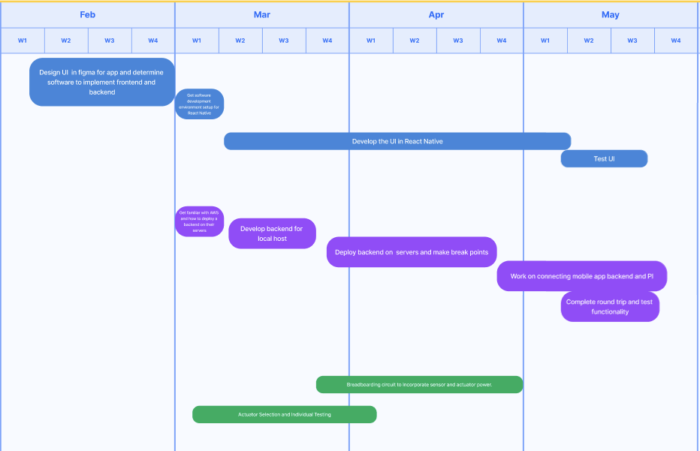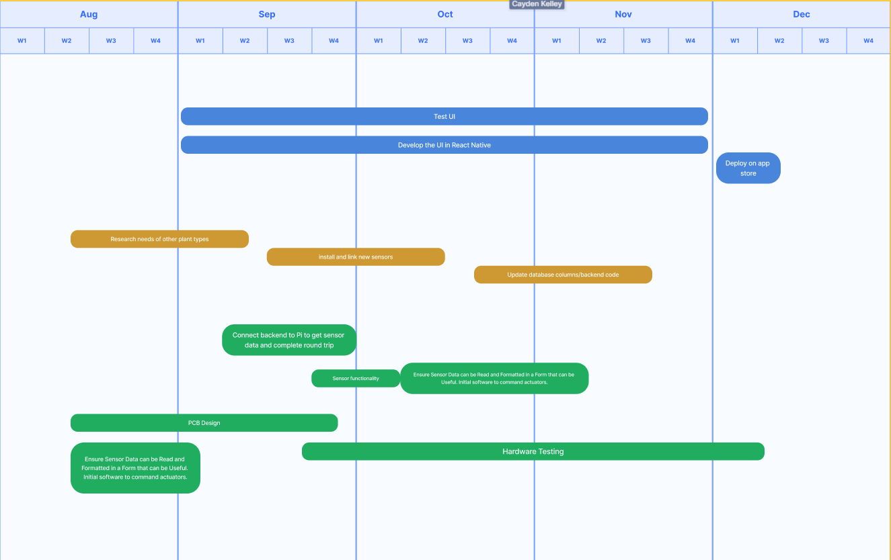

Advisor Meeting Summary:

Through our meeting with our project advisor, we determined that our group should prioritize both data and testing. With the progress we made last semester, we are in a good position to focus on a more productized iteration of our device. In order to ensure that the work we put into developing the hardware and software is meaningful, we will need to do significant testing on a variety of different plants to calibrate the fertilization system, watering system, and indicators of the plant’s current health. Having a device that not only works in theory but also has meaningful results is one of our top goals for the second semester of our project. Additionally, we will continue to work on integration between the hardware and software so that sensor data is accurately represented on the app and commands from the app can reach the device.

Note: Our initial advisor meeting took a while to set up, so we were unable to add the advisor meeting summary until recently. Dr. Shannon gave us the okay to resubmit this assignment now that we have the updated info.

Advisor Meeting Notes

-Focus areas:

-More data, more testing. Data on plants, communication etc.

-Focus area of full loop communication from app to server.

-Have more concrete values

-Now just putting more work overall

-Trial and error, subgroup meetings works well

-Plant testing for general data on what is considered healthy

-In pretty good shape for now

-Overall focus on integration,

-Representing the data is #1 priority

-Keep sending reports*********************

-Send reminder email morning of for next monday morning

Note: Cleared with Shannon. Resubmit with summary of advisor review.

-Meeting

-Put units on data, we can go with something more accurate and precise.

-Update schematics, documentation, etc. as we go

-Industry review panel will look through the documentation.

-1st semester was mostly for viability, 2nd more focus on documentation

-Business casual presentation

-Poster session same day as the review

-Meeting as a class online for a poster workshop (~1 month before end)

-Demo by the end of 2nd semester

-We can bring in physical device + app

-Preferrably 3rd iteration rather than 1st

-Next assignment: update design doc, website, reframing problem statement, etc.

-Engineering standards